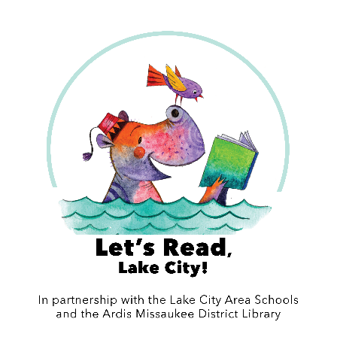

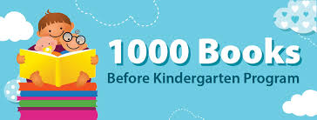

Dear Parents/Caregivers:
On behalf of the 1,000 Books Foundation, Let’s Read, Lake City!, Lake City Area Schools, and the Ardis Missaukee District Library, we invite you to participate in this FREE program which encourages you to read 1,000 books with your child before he or she starts kindergarten.
PROGRAM OVERVIEW
The concept is simple, the rewards are priceless. Read a book (any book) to your newborn, infant, and/or toddler. Also include books read by family, siblings, and caregivers. The goal is to have read 1,000 books (yes you can repeat books) before your precious one starts kindergarten.
Does it sound hard? Not really if you think about it. If you read just 1 book a night, you will have read about 365 books a year. That is 730 books in two years and 1,095 books in three years. If you consider that most children start kindergarten at around 5 years of age, you have more time than you think (so get started). The key is perseverance. Make it exciting!
HOW TO PARTICIPATE
- Pick up an Initial Record Sheet at the Ardis Missaukee District Library, a Read-Aloud Round-Up, the Health Department, or local Preschool, Head Start, or day care programs.
- Read with your child. Reading aloud teaches communication. It introduces concepts such as numbers, colors, shapes, and letters in a fun way. It also builds listening, memory, and vocabulary skills. Reading gives children information about the world around them.
- Keep track of the titles of the books that you read with your child. Make a record of what you are reading on the log sheet.
- Pick up a reading incentive/reward at the Ardis Missaukee District Library when you present each reading log sheet.
FREQUENTLY ASKED QUESTIONS
- Who can participate in this program? Any child from birth until he or she enters kindergarten can participate in the 1,000 Books Before Kindergarten program.
- How long will the program take? The program will take anywhere from a few months to a few years. The program is self-paced and will depend on how often you read together.
- How many of my children can participate? All children that have not started kindergarten. Make it even more fun and read as a family!
- Who do I contact with questions? You can call the Ardis Missaukee District Library at 839-2166. You can get information from Let’s Read Lake City! Facebook page: letsreadlakecity or email the group at letsreadlakecity@google.com. There is also general information and a young child reading list at www.1000booksbeforekindergarten.org.

